**Name**: Indir Lal

**CMS**: 053-22-0028

**LAB - 9**

# **Task – 1**

#include <iostream>

#include <string>

using namespace std;

struct Student

{

int id;

string name,depart,mail;

long phone;

};

int main()

{

Student record[5];

cout<<"This Program Takes Data For Five Students:\n";

for(int i=0;i<5;i++){

cout<<"\nEnter The Name of Student number "<<i+1<<": ";

cin.ignore();

getline(cin,record[i].name);

cout<<"\nEnter The ID of Student number "<<i+1<<": ";

cin>>record[i].id;

cout<<"\nEnter The Department of Student number "<<i+1<<": ";

cin.ignore();

getline(cin,record[i].depart);

cout<<"\nEnter The Email of Student number "<<i+1<<": ";

cin.ignore();

getline(cin,record[i].mail);

cout<<"\nEnter The Phone number of Student number "<<i+1<<": ";

cin>>record[i].phone;

cout<<"\n";

}

cout<<"\n\nThe Display of the given Data is: \n\n";

for(int i=0;i<5;i++){

cout<<"\nName of the student number "<<i+1<<" is: "<<record[i].name;

cout<<"\nID of the student number "<<i+1<<" is: "<<record[i].id;

cout<<"\nDepartment of the student number "<<i+1<<" is: "<<record[i].depart;

cout<<"\nEmail of the student number "<<i+1<<" is: "<<record[i].mail;

cout<<"\nPhone number of the student number "<<i+1<<" is: "<<record[i].phone;

cout<<"\n";

}

system("pause");

return 0;

}

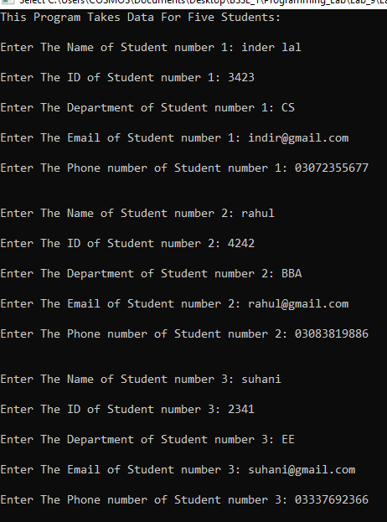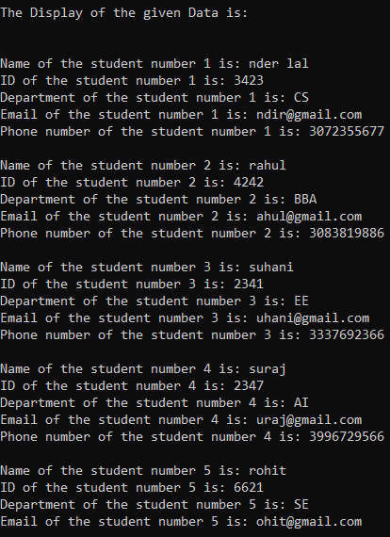

# **Task – 2**

#include <iostream>

#include <string>

using namespace std;

struct product{

string name,model;

int price;

};

void display(product rec[]);

int main()

{

product record[10];

cout<<"This Program takes data for 10 products and displays:\n\n";

for(int i=0;i<10;i++){

cout<<"Enter the Name of Product number "<<i+1<<": ";

cin>>record[i].name;

cout<<"Enter the Model Number of Product no: "<<i+1<<": ";

cin>>record[i].model;

cout<<"Enter the Price of Product number "<<i+1<<": ";

cin>>record[i].price;

cout<<"\n";

}

display(record);

return 0;

}

void display(product rec[]){

cout<<"\n\nThe Display of the given Record is: \n\n";

for(int i=0;i<10;i++){

cout<<"\nName of the Product number "<<i+1<<" is: "<<rec[i].name;

cout<<"\nModel Number of the Product number "<<i+1<<" is: "<<rec[i].model;

cout<<"\nPrice of the Product number "<<i+1<<" is: "<<rec[i].price;

cout<<"\n";

}

}

# **Task – 3**

#include <iostream>

#include <string>

using namespace std;

struct employee{

float emp_number,Bsalary,Hallowence,Med_allowence;

float tax,grosspay, netsalary;

string name;

};

employee empSalary(employee amount);// employee is data type of structure

void display(employee var);

int main(){

employee amount;

cout<<"Enter the Employee Number: ";

cin>>amount.emp_number;

cin.ignore();

cout<<"Enter the Employee Name: ";

getline (cin,amount.name);

cout<<"Enter the Basic Salary of Employee: ";

cin>>amount.Bsalary;

amount=empSalary(amount);//sending to function for calculation

display(amount);//sending to display function

cout<<"\n\n";

return 0;

}

employee empSalary(employee amount)// again amount is variable

{

amount.Hallowence=(10*amount.Bsalary)/100.0;

amount.Med_allowence=(5*amount.Bsalary)/100.0;

amount.tax=(4*amount.Bsalary)/100.0;

amount.grosspay=amount.Bsalary+amount.Hallowence+amount.Med_allowence;

amount.netsalary=amount.grosspay-amount.tax;

return (amount);//returning the structure

}

void display(employee var){

cout<<"\n\n***************************************\n\n";

cout<<" EMPLOYERS SALARY DETAILS \n\n";

cout<<"***************************************\n\n";

cout<<"\nEmplyee Number: "<<var.emp_number;

cout<<"\nEmplyee Name: "<<var.name;

cout<<"\nBasic Salary: "<<var.Bsalary;

cout<<"\nHouse Allowence: "<<var.Hallowence;

cout<<"\nMedical Allowence: "<<var.Med_allowence;

cout<<"\nGross Salary: "<<var.grosspay;

cout<<"\nTax Deduction : "<<var.tax;

cout<<"\nNet Salary: "<<var.netsalary;

}

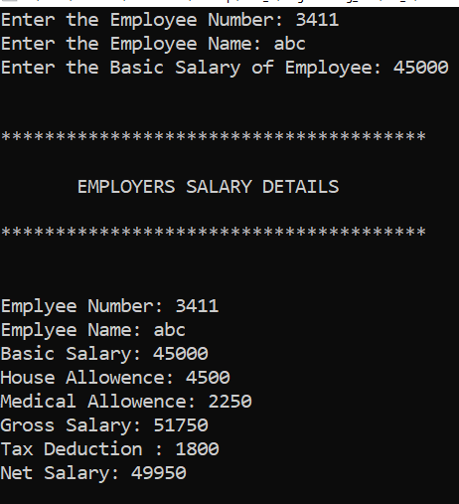

# **Task – 4**

#include <iostream>

using namespace std;

int main(){

int arr[5]={12,33,56,67,78};

int *ptr;

ptr=&arr[0];

cout<<"This Program Displays The 5 Values of Array and thier address through Pointers: \n";

cout<<"\nValues of the Array:\n\n";

for(int i=0;i<5;i++) {

cout<<arr[i]<<" ";

}

cout<<"\nAddress of the Array through Pointers:\n\n";

for(int i=0;i<5;i++){

cout<<ptr+i<<"\n";

}

return 0;

}

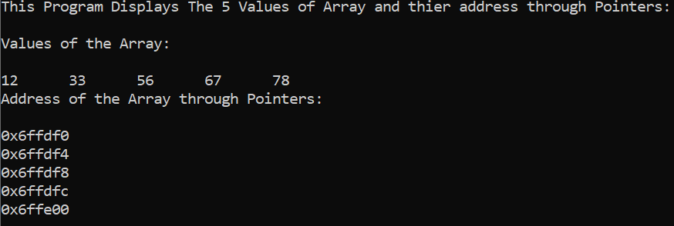

# **Task – 5**

#include <iostream>

using namespace std;

void bubbleSort(int *ptr);

int main(){

int arr[7]={76,23,45,15,232,170,128};

cout<<"The Original/Unsorted Array values are: \n\n";

for(int i=0;i<7;i++){

cout<<arr[i]<<" ";

}

cout<<"\n\n";

bubbleSort(arr);

cout<<"\n\n";

return 0;

}

void bubbleSort(int *ptr){

int temp;

cout<<"The Sorted Array values are: \n\n";

for(int i=0;i<7;i++){

for(int j=i+1;j<7;j++){

if(*(ptr+i)>*(ptr+j)){

temp=*(ptr+i);

*(ptr+i)=*(ptr+j);

*(ptr+j)=temp;

}

}

}

for(int i=0;i<7;i++){

cout<<*(ptr+i)<<" ";

}

}

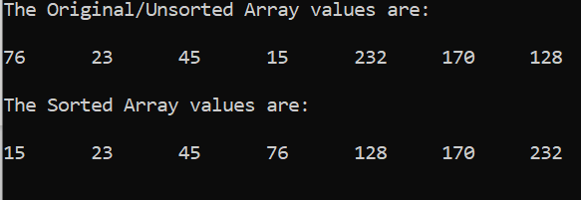

# **Task – 6**

#include <iostream>

using namespace std;

int main(){

int arr[10];

int *ptr;

int a,b=0;

cout<<"This Program takes input upto 10 values \n";

cout<<"stores them in an Array through pointers and displays values through pointer:\n\n";

for(int i=0;i<10;i++){

cout<<"Enter Value Number "<<i+1<<": ";

cin>>a;

ptr=&a;

arr[i]=*ptr;

}

ptr=arr;

cout<<"\n\nThe Display through pointers is:\n\n";

for(int i=0;i<10;i++){

cout<<"Value number "<<i+1<<" is: "<<*(ptr+i)<<"\n";

}

cout<<"\n\nThe Display through Array is:\n\n";

for(int i=0;i<10;i++){

cout<<"Value number "<<i+1<<" is: "<<arr[i]<<"\n";

}

cout<<"\nEnter any Number to search it from array (Through Pointer): ";

cin>>a;

for(int i=0;i<10;i++){

if(a==*(ptr+i)){

cout<<"The Number is on Memory location: "<<(ptr+i);

cout<<"\nThe number is on Array Location number: "<<i+1<<"\n\n";

b++;

}

}

if(b==0)

cout<<"\nThe Entered number is not in the Array:\n\n";

return 0;

}

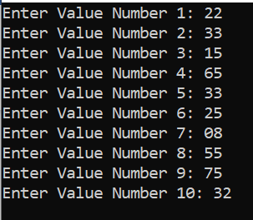

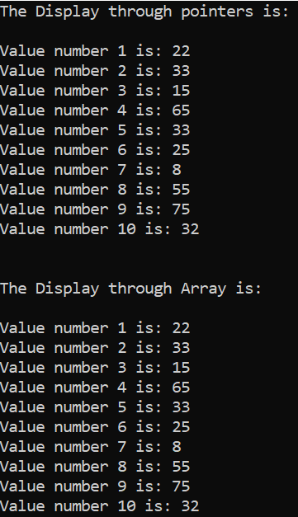

# **Task – 7**

#include <iostream>

using namespace std;

void swap(int *a,int *b);

int main(){

int a=25,b=60;

cout<<"In Main Function:\n";

cout<<"The Value of 1st variable a is "<<a;

cout<<"\nThe Value of 2nd variable b is "<<b;

swap(&a,&b);

return 0;

}

void swap(int *a,int *b){

int *c;

c=a;

a=b;

b=c;

cout<<"\n\n In Function Swap:\n\n";

cout<<"The Swapped/Exchanged Values are: \n\n";

cout<<"The Value of 1st variable a is "<<*a;

cout<<"\nThe Value of 2nd variable b is "<<*b;

}

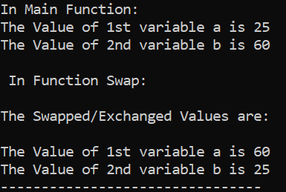

# **Task – 8**

#include <iostream>

using namespace std;

struct student {

string name;

int id;

int mark[3];

};

void inputstudent(student *ptr);

void outputstudent(student *ptr);

int main(){

student stu;

student *stuptr=&stu;

inputstudent(&stu);

outputstudent(stuptr);

return 0;

}

void inputstudent(student *ptr){

cout<<"Taking Input in Funtion (Input):\n\n";

cout<<"Enter the Name of Student: ";

getline(cin,(*ptr).name);

cout<<"Enter the ID of Student: ";

cin>>(*ptr).id;

for(int i=0;i<3;i++){

cout<<"Enter the Marks for Subject "<<i+1<<": ";

cin>>(*ptr).mark[i];

}

}

void outputstudent(student *ptr){

cout<<"\n\nThe Output through OutputFunction is:\n";

cout<<"\n\nName of the student is: "<<(*ptr).name;

cout<<"\nID of the Student is: "<<(*ptr).id;

for(int i=0;i<3;i++){

cout<<"\nThe Marks of Subject "<<i+1<<" is: "<<(*ptr).mark[i];

}

}

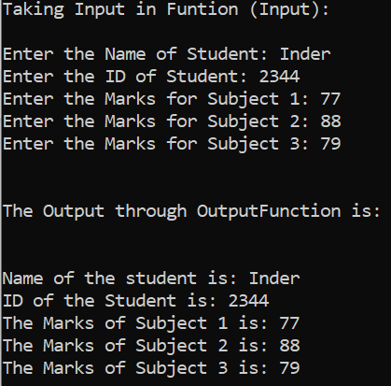

# **Task – 9**

#include <iostream>

using namespace std;

struct student {

string name;

int id;

int *mark;

};

void inputstudent(student *ptr,int a);

void outputstudent(student *ptr,int a);

int main(){

student stu;

int num;

student *stuptr=&stu;

cout<<"How many marks do you want to enter: ";

cin>>num;

stu.mark=new int [num];

inputstudent(&stu,num);

outputstudent(stuptr,num);

return 0;

}

void inputstudent(student *ptr,int num){

cout<<"Taking Input in Funtion (Input):\n\n";

cin.ignore();

cout<<"Enter the Name of Student: ";

getline(cin,(*ptr).name);

cout<<"Enter the ID of Student: ";

cin>>(*ptr).id;

for(int i=0;i<num;i++){

cout<<"Enter the Marks for Subject "<<i+1<<": ";

cin>>(*ptr).mark[i];

}

}

void outputstudent(student *ptr,int num){

cout<<"\n\nThe Output through OutputFunction is:\n";

cout<<"\n\nName of the student is: "<<(*ptr).name;

cout<<"\nID of the Student is: "<<(*ptr).id;

for(int i=0;i<num;i++){

cout<<"\nThe Marks of Subject "<<i+1<<" is: "<<(*ptr).mark[i];

}

}

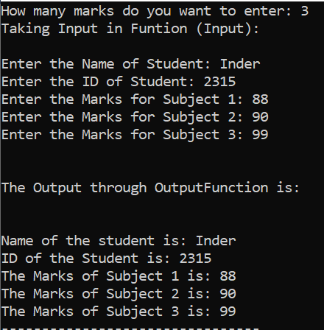

#include <string>

#include <iostream>

using namespace std;

struct Student {

string name;

int id; int

mark[3];

};

void inputStudent(Student* ptr);

void outputStudent(Student* ptr);//function prototype for getting input

// some other function for printing the details

//*********************** Main Function ************************// int

int main () {

Student stu; // declaring an Student object

Student* stuPtr = &stu; // defining a pointer for the object

inputStudent(&stu);

// calling function to get input into the object

// calling the other function to print the details of the object

return 0;

}

void inputStudent(Student*ptr)

{

Student st;

cout<<"Enter the name of student:"<<endl;

cin>>st.name;

cout<<"Enter the id of student:"<<endl;

cin>>st.id;

for(int i=0; i<3; i++)

{

cout<<"Enter marks of subject "<<i+1<<":"<<endl;

cin>>st.mark[i];

}

ptr=&st;

outputStudent(&stu);

}

void outputStudent(Student*ptr)

{

Student st;

cout<<"The name of student is "<<st.name[0]<<endl;

cout<<"The id of student is "<<st.id<<endl;

for(int i=0; i<3; i++)

{

cout<<"The marks of subject "<<i+1<<":"<<st.mark[i]<<endl;

}

ptr=&st;

}